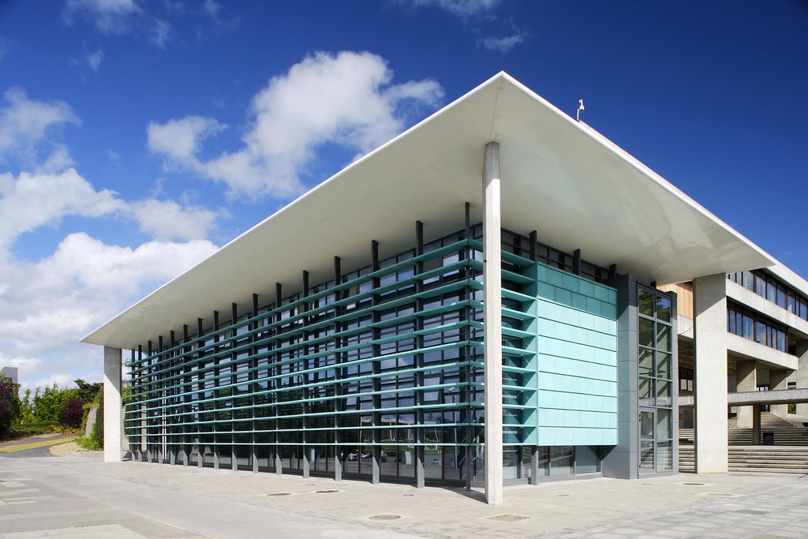
UCD Research, Innovation & Impact
Research Careers &
Professional Development
Planning Document
Postdoc Research Fellow Level 1 & Level 2

At UCD, our research makes a difference. We deliver research and innovation at scale and in areas of national and global significance by prioritising excellence and impact, investing in our people and providing a culture and environment in which they are supported to deliver across the university's four strategic themes.

Postdoc Name: PI Name: School/Research Institute: Date Started Current Position:

Research Careers & Professional Development Framework

Development Category | Development Sub-Category | Indicators PD Fellow Level 1 | Indicators PD Fellow Level 2
Research & Research Management  Ability to translate critical and original thinking into published research and to manage a research project through all stages of the lifecycle | Discipline Methodologies
 | Research Context
 | Research Project Management
 | Grant Writing
 | Writing for Research Publications
 | Creative/original thinking
Personal & Professional Excellence  Ability to manage self and others an do operate at a level that is comparable to the highest international standards | Communication & Presentation
 | Networking and collaboration
 | Leadership and Interpersonal Skills
 | Self Management & Career Development
Teaching Learning & Mentoring  Ability to transfer knowledge to individuals and groups using a variety of learning methods | Small Group Teaching
 | Mentoring
 | Flexible Learning and Delivery
Innovation & Transferable Skills  Acquiring knowledge and experience that support alternative career options | Innovation Process
 | IP Management
 | Business Planning
 | Policy Development
 | Organisation Development
 | Commercialisation of Research

1. A. Postdoc Research Fellow Level 1: Self-Assessment to be Completed Prior to Planning Meeting with PI

Development Category | Development Sub- Category | Indicators PD Fellow Level 1 | Evidence of Competence to Date  (Use examples from your studies and/or previous research positions to indicator competence in any of the areas described. Be as specific as you can)
Research & Research Management  Ability to translate critical and original thinking into published research and to manage a research project through all stages of the lifecycle | Discipline Methodologies
 | Research Context
 | Research Project Management
 | Grant Writing
 | Writing for Research Publications
 | Creative/original thinking
Personal & Professional Excellence  Ability to manage self and others an do operate at a level that is comparable to the highest international standards | Communication & Presentation
 | Networking and collaboration
 | Leadership and Interpersonal Skills
 | Self Management & Career Development
Teaching Learning & Mentoring  Ability to transfer knowledge to individuals and groups using a variety of learning methods | Small Group Teaching
 | Mentoring
 | Flexible Learning and Delivery
Innovation & Transferable Skills Acquiring knowledge and experience that support alternative career options | Innovation Process
 | IP Management
 | Business Planning
 | Policy Development
 | Organisation Development
 | Commercialisation of Research

- B. Postdoc Research Fellow Level 2: Self-Assessment to be Completed Prior to Planning Meeting with PI

Development Category | Development Sub-Category | Indicators PD Fellow Level 2 | Evidence of Competence to Date  (Use examples from your studies and/or previous research positions that indicate competence in the areas described. Be as specific as you can.)
Research & Research Management  Ability to translate critical and original thinking into published research and to manage a research project through all stages of the lifecycle | Discipline Methodologies
 | Research Context
 | Research Project Management
 | Grant Writing
 | Writing for Research Publications
 | Creative/original thinking
Personal & Professional Excellence  Ability to manage self and others an do operate at a level that is comparable to the highest international standards | Communication & Presentation
 | Networking and collaboration
 | Leadership and Interpersonal Skills
 | Self Management & Career Development
Teaching Learning & Mentoring  Ability to transfer knowledge to individuals and groups using a variety of learning methods | Small Group Teaching
 | Mentoring
 | Flexible Learning and Delivery
Innovation & Transferable Skills  Acquiring knowledge and experience that support alternative career options | Innovation Process
 | IP Management
 | Business Planning
 | Policy Development
 | Organisation Development | -
 | Commercialisation of Research

- Research Careers & Professional Development Plan – to be agreed between Postdoc Research Fellow and PI

Development Category | Development Objective(s)  Specify particular sub-category for development | Strategy for Development  Identify available course (review list of potential courses) and/or other intervention for developing skill | Target Date  Agreed date as to when this development will happen | Date Reviewed Use page 6 for adding comments
Research & Research Management
Ability to translate critical and original thinking into published research and to manage a research project through all stages of the lifecycle
Personal & Professional Excellence
Ability to manage self and others an do operate at a level that is comparable to the highest international standards
Teaching Learning & Mentoring
Ability to transfer knowledge to individuals and groups using a variety of learning methods
Innovation & Transferable Skills
Acquiring knowledge and experience that support alternative career options

- Record of Meetings Between PD Fellow and PI
First Planning Meeting (additional comments)
Interim (mid-contract) Review and Feedback Date:
(PI in conjunction with PD Fellow to insert a brief summary of progress 12 months into contract)
Final (end of contract) Review and Feedback Date:
(PI in conjunction with PD Fellow to insert summary of discussion to capture PD Fellow’s assessment of development, key feedback points and any other aspects of the discussion deemed worthy for inclusion).

***Log in and Update the Postdoc Development Portal***

The UCD Postdoc Development Portal has been created to record career development meetings with your PI, as well as keep track of your RMS profile, your contract information and events you have booked onto.

How to log in to the Postdoc Development Portal:

Open UCD Connect
Click and log in to InfoHub
Select the Human Resources tab at the top of the screen
Click on My Development Workspace
Record date of meeting with PI

Research Skills & Career Development Planning Document Page 6 of

